
.
TWENTY-SECOND SUNDAY IN ORDINARY TIME  SEPTEMBER 2, 2018


Sat. Sept. 1 VIGIL-TWENTY-SECOND SUNDAY IN ORDINARY TIME
4:00pm Robert Anthony Arredondo by Family

Sun. Sept. 2 TWENTY-SECOND SUNDAY IN ORDINARY TIME
8:30am Anna Swingle by Frank Mulcahy
9:45am For the People of the Parish

Mon. Sept. 3 SAINT GREGORY THE GREAT, POPE & DOCTOR
8:30am Communion Service & Novena of the Miraculous Medal

Thurs. Sept. 6 WEEKDAY TWENTY-SECOND WEEK IN ORDINARY TIME
8:30am Communion Service & Rosary

Sat. Sept. 8 VIGIL-TWENTY-THIRD SUNDAY IN ORDINARY TIME
4:00pm Bill Jansen by Mary Knowles

Sun. Sept. 9 TWENTY-THIRD SUNDAY IN ORDINARY TIME
8:30am Marianne Proch by M/M Protus Phillips
9:45am For the People of the Parish

The Altar Candles are donated
for the week in memory of
John Stoia by
Ron & Marie Natoli.

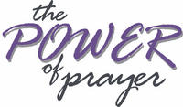
Parishioners who are sick and in need
of prayers can be added to our prayer
list by calling the Parish Office at
570-842-4995. Please pray for:
Sam Martino, Reilly Canas,
Lenny Olechna, Betsy Kressler,
Joseph Ferenczi, P.J. Cappola, Helen Zerbe, Paula Peet,
Carmel Ann Maxson, Nicholas Pierotti, Bob Jantz, Susan Golombos, Joseph Falchek, Donna Jean Marabella, Jerry White, Jeanne Tierney, Arline Chumacas, Jenny Filingo, Jennifer Simis, Alan Lemech,
Phyllis Braun, Richard Major, Bill Vockroth, Vonette Castelblanco, Jane Colwell, Jeanne Kopyta, Muriel Calame, Jamie Jantz,
Donna Lewis, Jason Scott Taylor,Joanne Arredondo, Vincent Natoli, and all the sick of the Parish.

Our Pilgrim Statue of the Blessed Virgin Mary

If she has not yet visited your home and you would like information or to sign up to have the Statue visit your home, please call Pat Manago at 570-848-2284.
This is where the statue will be traveling in the
weeks to come: 9/02-Nawrocki Family 9/09-Manago Family
9/16-OPEN 9/23-OPEN
9/30-OPEN 10/7-OPEN


STEWARDSHIP OF TALENT:
Sept. 2, 2018 22ND SUNDAY IN ORDINARY TIME
LECTORS:
Sept. 1st 4:00pm Sharon Lenzer
Sept. 2nd 8:30am Susan Pilosi
9:45am Kathy Fossetta
EXTRAORDINARY MINISTERS OF THE EUCHARIST:
Sept. 1st 4:00pm Alan Hynes/Bruce Negri
Sept. 2nd 8:30am Marilyn Croak/Pat Manago
9:45am Daria Killian/Amanda Proch
ALTAR SERVERS:
Sept. 1st 4:00pm Alan Hynes
Sept. 2nd 8:30am Veronica Yanulavich
9:45am Ayden Hull
HOSPITALITY & USHERS:
Sept. 1st 4:00pm Andy Kelemen/Victor Benfatti
Sept. 2nd 8:30am Ed Snyder/Tom Volpe
9:45am Frank Kopyta/Richard Erazmus
Sept. 9, 2018 23RD SUNDAY IN ORDINARY TIME
LECTORS:
Sept. 8th 4:00pm Lyne Van Houtte
Sept. 9th 8:30am Judy Martino
9:45am Sharon Lenzer
EXTRAORDINARY MINISTERS OF THE EUCHARIST:
Sept. 8th 4:00pm Mary Rounsavill/Ron Natoli
Sept. 9th 8:30am Tony Butel/Veronica Yanulavich
9:45am Tony Butel/Pat Manago
ALTAR SERVERS:
Sept. 8th 4:00pm Alan Hynes
Sept. 9th 8:30am Susan Pilosi
9:45am Kathy Fossetta
HOSPITALITY & USHERS:
Sept. 8th 4:00pm Andy Kelemen/Victor Benfatti
Sept. 9th 8:30am Tom Volpe/Richard Colwell
9:45am Richard Erazmus/Tom Quinn

STEWARDSHIP OF TREASURE:


8/26/18
ENVELOPES (77): $ 1550.00
LOOSE: $ 424.00
UTILITIES (1): $ 10.00
SCHOOL (36): $ 251.00
: INSURANCE (2): $ 20.00
ONLINE (3): $ 63.00
TOTAL: $ 2318.00

08/26 08/19 08/12 08/05
PEOPLE ATTENDING: 4:00PM 86 78 81 88
8:30AM 51 65 55 79
9:45AM 79 101 50 56

THANK YOU FOR YOUR CONTINUED SUPPORT

WE STILL HAVE SEATS AVAILABLE

BUT WE MUST HAVE ALLL RESERVATIONS IN BEFORE
SEPTEMBER 10


SIGHT & SOUND
Saint Rita’s is sponsoring a trip to Lancaster to see Sight & Sound. This year’s production is “JESUS”.

WEDNESDAY, OCT. 17, 2018
PRICE-$118.00/PP
(Children 11 & under-$82)

INCLUDES: BUS, SHOW, & LUNCH AT SHADY MAPLE. BENEFITS ST. RITA CHURCH
FOR MORE INFO:
CALL MARY AT 570-676-3711

ENVELOPE FUNDRAISER
Our Envelope fundraiser continues. This year we are replacing the floor in the Church basement, and we hope to do some work on the upper parking lot. Your donations help the parish with needed repairs and improvements that are not able to be addressed with just our regular collections. All monies collected stay in the parish for building projects.
TOTAL TO DATE: $11,624.00

THANK YOU FOR YOUR GENEROSITY

CLIFTON TOWNSHIP VETERANS MEMORIAL DEDICATION CEREMONY
Sunday, September 9 at 2:00 pm, Clifton Township will dedicate the new Veterans Monument that will serve as a remembrance of the brave Americans who have fought to keep us free. Light refreshments will be served immediately following the ceremony at Clifton Township Building, 361 State Route 435, Clifton Twp., Pa.

REGISTRATION FOR FAITH FORMATION CLASSES
Registrations will be taken every Sunday following the 9:45 Mass starting September 9th.
Classes will begin on September 30th.
Please register early so that we can plan for materials and room assignments.

FIRST FRIDAY MARIAN DEVOTION AND HEALING MASS—SEPTEMBER 7TH
Come and pray with us on Friday, September 7th at 6:30pm in Saint Lucy’s Church, 949 Scranton St., Scranton. The Rosary and prayers will be led by Adele Garofalo. The Mass begins at 7pm which includes healing prayers and an anointing. Music will be provided by Ernie Pappa. All are invited to come to deepen their devotion to Mary and to pray for healing and for peace in the world.

CATHOLIC CHARISMATIC RENEWAL
The Catholic Charismatic Renewal of the diocese of Scranton will offer its Fall Retreat on Friday & Saturday, September 14 & 15, at the Villa of Our Lady in Mount Pocono. Fr. Richard McAlear OMI will lead the retreat which will include teachings, Confession, Mass and prayers for healing. You can commute for all or part of the retreat or can stay overnight at the Villa. The main program will begin at 8pm on Friday and conclude at 8:30pm on Saturday. Registration is required, and the fee includes 3 meals on Saturday. For additional information and registration details, contact the office of the Catholic Charismatic Renewal, PO Box 3306, Scranton, PA 18505-0306; phone 570-944-2214; or email xxrenewal@comcast.net. Deadline for registrations is September 5.



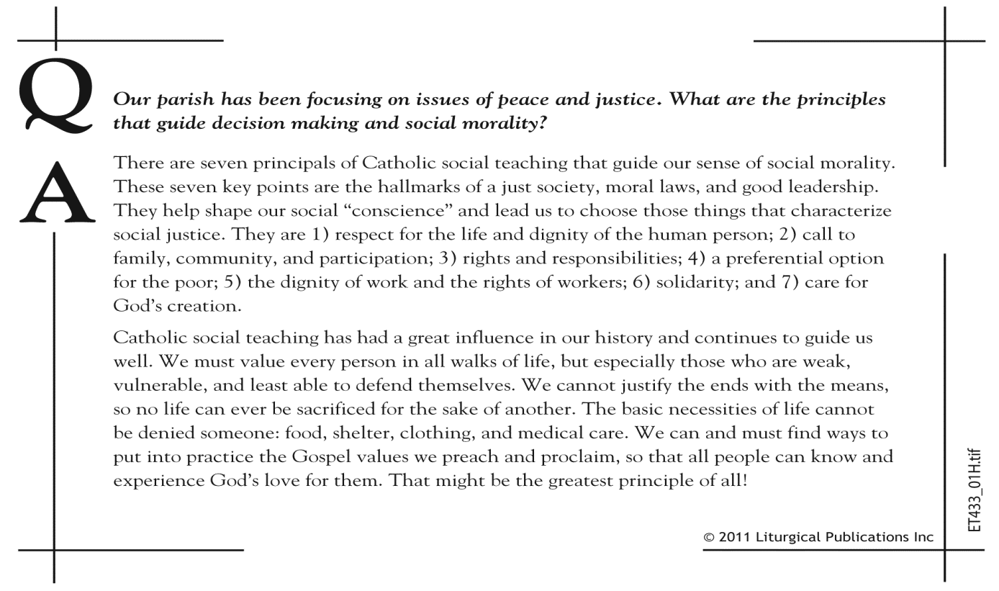

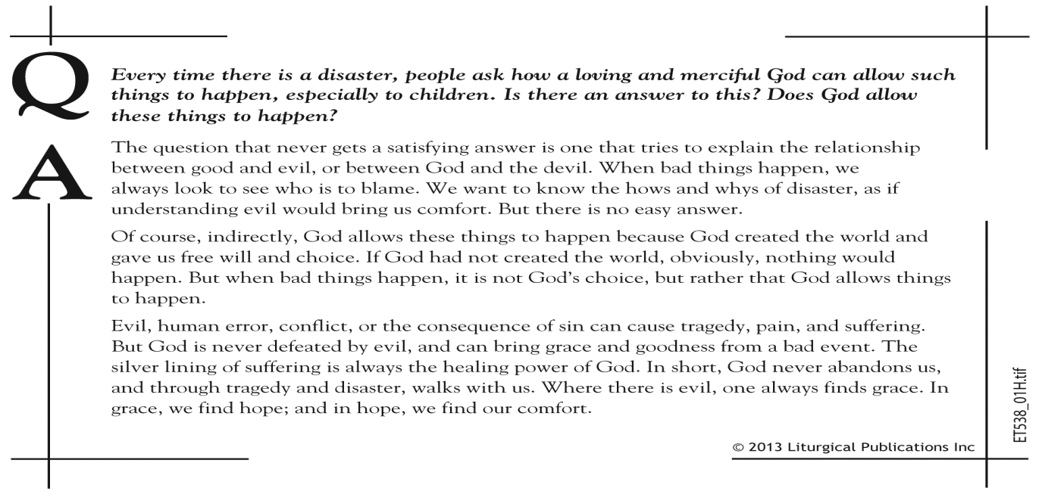

TWENTY-SECOND SUNDAY IN ORDINARY TIME

“All good giving and every perfect gift are from above, coming down from the Father of lights... Humbly welcome the word that has been planted in you and is able to save your souls. Be doers of the word and not hearers only, deluding yourselves. Religion that is pure and undefiled before God and the Father is this: to care for the orphans and widows in their affliction and to keep yourself unstained by the world.”

As we reflect on the word each week, we are encouraged to not just hear or read, but to decide how it directs me to live it and put it into practice. From the first page of the bible, care for the oppressed, widows and orphans was a key measure for being a faithful person. The history of the church celebrates the heroes who reached out to the needy, beginning in the Acts of the Apostles. Saints like Vincent de Paul, Mother Katherine Drexler, saw needs and acted upon them.

In his exhortation ‘Rejoice and Be Glad’ Pope Francis indicates that the Beatitudes are our identity card. So, if anyone asks, ‘What must I do to be a good Christian?’, the answer is clear. We have to do each in our own way what Jesus told us in the Sermon on the Mount. Saint James and Pope Francis tell us ‘we are a people of the beatitudes’.



HIS WORD TODAY
BY REV. WILLIAM J. REILLY

A FRESH PERSPECTIVE ON
THE SUNDAY READINGS

